BASF Chemicals Database Project Report

By: Cole Heausler, Kyle King,
Seth Auzane, Benjamin Gutowski

CSC 4402: Introduction to Database Systems

Introduction:
BASF is one of the world’s largest chemical manufacturers, they operate a refinery within Baton Rouge, Louisiana. This facility primarily focuses on synthesizing, processing and distributing various chemical products used in plastics, coatings and even agriculture. Since an operation such as this requires continuous running, it depends on a high amount of accurate data relating to raw materials, equipment, product tracking, environmental monitoring, etc. As production gets larger, BASF will require a structured and reliable information system that can be integrated across the refinery.
A dedicated relational database would ensure accuracy, traceability and assist in real-time decision making on site. The refinery handles thousands of updates and transactions, some of these include inventory updates, maintenance logs, shipment scheduling. These updates cannot be managed properly through manual or fragmented systems, thus requiring a database. A database enables centralized storage, regular reporting, and supports queries for operational efficiency. Ultimately developing this database supports BASF’s goals in streamlining workflow management and operational reliability within its Baton Rouge refinery.

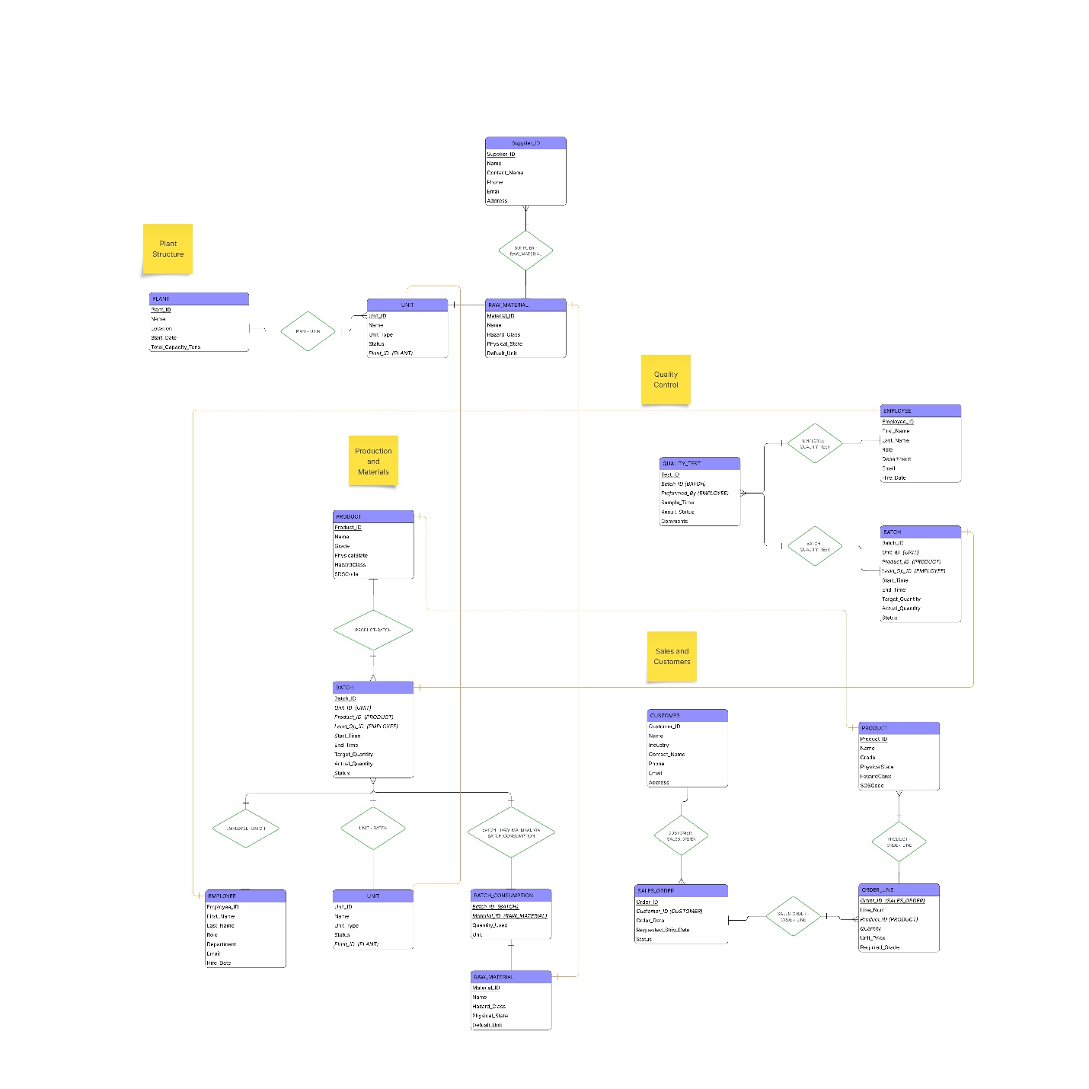
(For a higher quality version, please look at the associated .pdf file found within the /report/ folder.)

Relationship Schema:
PLANT – UNIT  Relationship: Plant contains Units (one-to-many)  Connects each Plant to its operational Units, indicating where specific processing units belong within the Baton Rouge refinery’s physical structure. | SUPPLIER – RAW_MATERIAL  Relationship: Suppliers provide Raw Materials (one-to-many)  Links each Raw Material to the Supplier(s) that delivers it. This relationship ensures traceability of hazardous materials and supports procurement workflows. | UNIT – BATCH  Relationship: Unit produces Batch (one-to-many)  Associates each production Batch with the Unit in which it was processed. This supports production tracking, equipment scheduling, and capacity planning. | PRODUCT – BATCH  Relationship: Batch produces Product (many-to-one)  Connects a Batch to the Product it generates, enabling product-level traceability, yield analysis, and quality reporting.
EMPLOYEE – BATCH  Relationship: Employee leads/works on Batch (one-to-many)  Links a Batch to the Employee serving as Lead Operator. This supports accountability, safety audits, and labor reporting. | BATCH – RAW_MATERIAL (via BATCH_CONSUMPTION)  Relationship: Batch consumes Raw Materials (many-to-many)  A many-to-many associating table showing which Raw Materials and quantities were used in each Batch, essential for inventory management and regulatory compliance. | BATCH – QUALITY_TEST  Relationship: Batch undergoes Quality Tests  (one-to-many)  Each Quality Test is tied to a specific Batch, enabling QC tracking, approval workflows, and release documentation. | EMPLOYEE – QUALITY_TEST  Relationship: Employee performs Quality Tests (one-to-many)  Links the Employee who performed the test to the Quality_Test record for accountability and compliance.
CUSTOMER – SALES_ORDER  Relationship: Customer places Sales Orders (one-to-many)  Associates each Sales Order with the Customer, supporting order fulfillment and client management. | SALES_ORDER – ORDER_LINE  Relationship: Sales Order contains Line Items (one-to-many)  Breaks each Sales Order into multiple Order Lines, enabling itemized product quantities, grades, and pricing. | PRODUCT – ORDER_LINE  Relationship: Order Line requests Product (one-to-many)  Links each Order Line to the Product being sold, enabling accurate shipment and production-to-sales alignment.

Test Queries and Outputs:
The images associated with each query are the SQL Query followed by the Results (as printed in the UI)

Test 1: Select the names and IDs of all Employees who've been assigned a Quality Test, and how many tests they've been assigned:
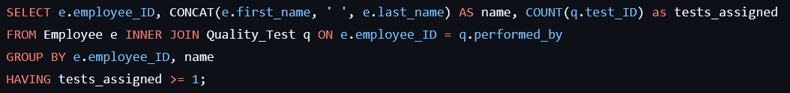
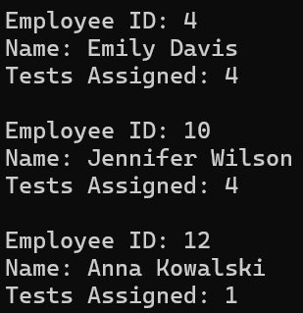

Test 2: Select the names, units, and IDs of all Products and the Total Quantity ordered for each:
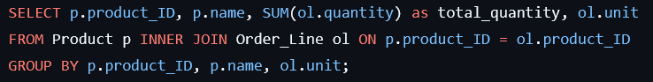
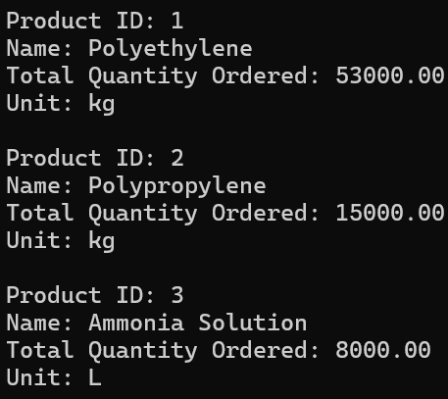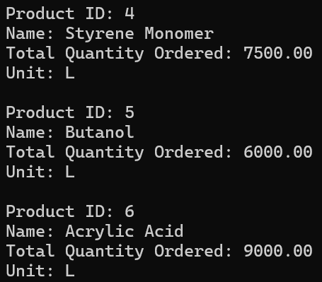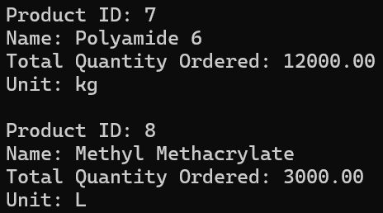

Test 3: Select the names, units, and IDs of all Raw Materials and the Total Quantity used in Batch Consumptions
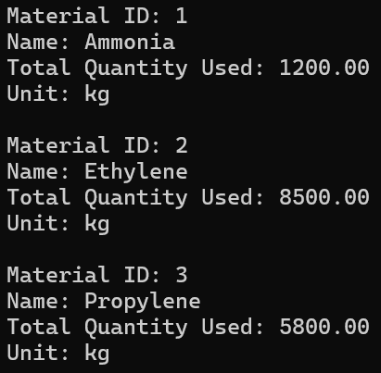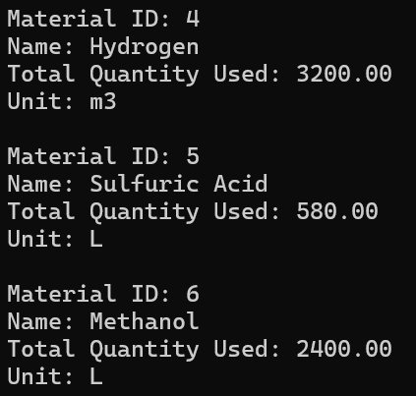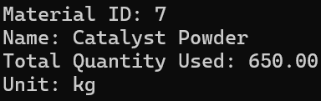
Test 4: Select the names, locations, and IDs of all Plants and their total production quantity from complete Batches
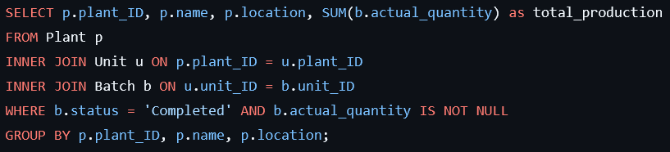
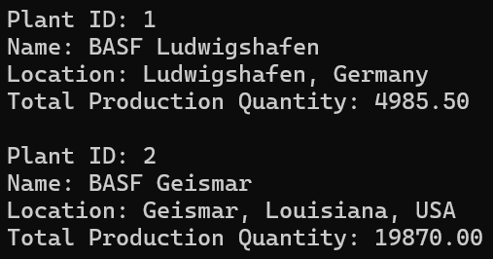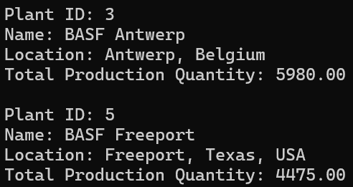

Test 5: Select the names, industries, and IDs of all Customers along with their total Order count and value
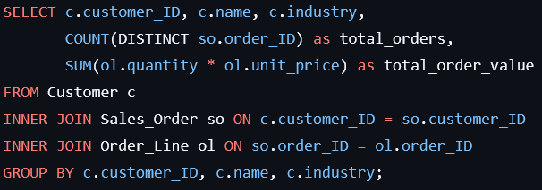
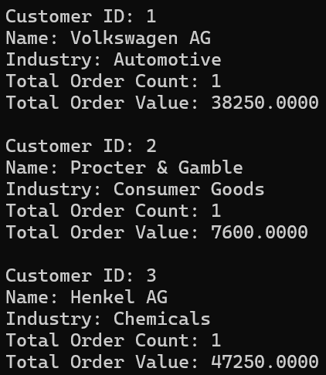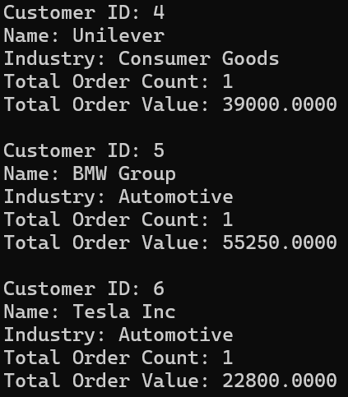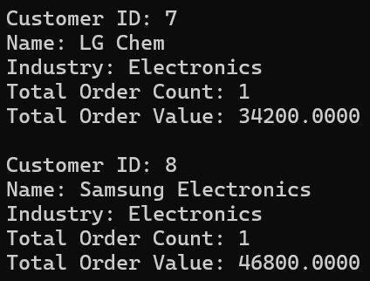

These test queries were designed to validate correctness, reliability and behavior of each entity and relation within the schema. The test cases are primarily focused on verifying entity relationship integrity and accessibility by looking for data that would be needed for everyday plant operations. The outputs show that relationships between entities were functioning as expected, especially regarding foreign key constraints or orphaned records, validating that the database system performs reliably, consistently, ensures internal integrity and supports possible operational needs for BASF.

Application User Interfaces:
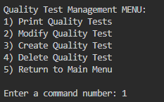
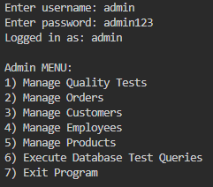
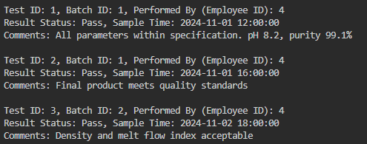
(Admin test version, seen here.)

The user interface regarding the BASF database is based on a menu drive command line UI. The purpose of which is to ensure that users can safely interact with the SQL database (CRUD functionality) without writing SQL directly. Initially it opens with a connection prompt, ensuring a proper Python to MySQL connection is achieved. The user will then input application credentials (admin/user, see README for more information) to determine permission levels and prevent possible security issues. The menu when logged in (see above) is displayed as such.
To navigate from a particular menu, the user must input the number associated with the menu option.
This can do a multitude of actions:
- Move to submenu or to the previous menu.
- Manage data found within an entity.
- Create, Read, Update, or Delete (CRUD) data.
- Execute the Test Queries provided above.
Once an option has been selected, the user may be prompted to fill in a particular field depending on the action chosen (CRUD operations, fill in: IDs, names, dates, etc.). Visually each menu is structured similarly to its brethren: a title/header line indicating the current context, a body/menu listing of available options with a brief description of its action.
The goal of creating this interface design was to:
- Ensure user experience was simple and reliable
- Inexperienced users would be unable to modify SQL code directly
- Data manipulation and testing, was straight forward, consistent and preformed safely

Participation Details:

Cole Heausler – ,ER Diagram and Relationship Schema Construction, Secondary Quality Assurance, Project Report Writer.
Benjamin Gutowski – Primary Code Writer, Application UI Programming, Database Schema Construction, README writer
Kyle King – Secondary Code Writer, Test Case Tester, Data Creator & Constructor
Seth Auzanne – Test Queries Writer, Primary Quality Assurance, Report Proof-reader

